CCD Algorithm

**Application to EU Style Factors  
ERC or Risk Parity portfolios**

**In Excel VBA**

This short note is a direct application of the Juan-Carlos Richard and Thierry Roncalli article available on [**ssrn**](https://papers.ssrn.com/sol3/papers.cfm?abstract_id=2595051). The cyclical coordinate descent (CCD) they describe is a fantastic tool in that you can solve many convex optimization problems without the need for an optimiser/solver, just using an iterative algorithm.

**We apply here the cyclical coordinate descent (CCD) algorithm to compute the weight of the ERC portfolio in an Excel VBA framework.**

Note: We make no distinction between Equally Weighted Risk Contribution (ERC) and Risk Parity portfolios. Both define here a portfolio where all its components have the same budget of risk.

# CCD Algorithm

**In short going from the optimisation program of a Risk Budgeted portfolio**

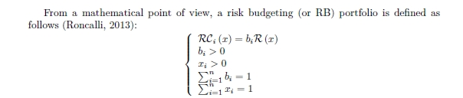

**From differentiating the Lagrangian function they deduce an iterative algorithm to compute the RB weigths**



# Portfolio of EU Style Premia

We implement the **CCD** iterative algorithm in Excel VBA (see appendix for command lines).

We now have an efficient tools to compute easily the ERC portfolio in Excel.

Let s illustrate this with a portfolio aiming at investing in 5 Style Premia on EU stocks. : Low Beta, Momentum, Quality, Low Size, Value. This can be easily extended to

Below are the volatility and correlation matrix (weekly return, since 2011).

We would note that the Value style premia presents interesting diversification properties counterbalancing its higher volatility.

|  |  |  |  |  |  |
| --- | --- | --- | --- | --- | --- |
|  | **Low Beta** | **Momentum** | **Quality** | **Low Size** | **Value** |
| **σ** | **0.79%** | **0.95%** | **1.03%** | **1.11%** | **1.65%** |

|  |  |  |  |  |  |
| --- | --- | --- | --- | --- | --- |
|  | **Quality** | **Low Beta** | **Momentum** | **Low Size** | **Value** |
| **Low Beta** | 1.0 | 0.6 | 0.5 | 0.1 | -0.4 |
| **Momentum** | 0.6 | 1.0 | 0.4 | 0.0 | -0.4 |
| **Quality** | 0.5 | 0.4 | 1.0 | 0.0 | -0.3 |
| **Low Size** | 0.1 | 0.0 | 0.0 | 1.0 | 0.6 |
| **Value** | -0.4 | -0.4 | -0.3 | 0.6 | 1.0 |

# Excel VBA ERC_CCD() function

We can know compute the covariance matrix and the ERC portfolio using the ERC_CCD() function developed in VBA.

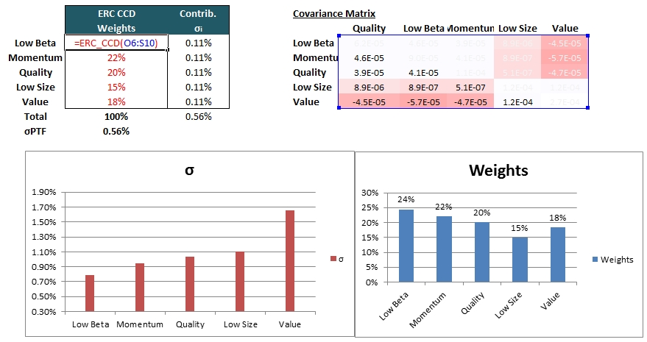

We’ll note that despite a higher volatility the ERC portfolio would have a greater weight in Value vs. Low Size. This is due to the good diversification power of the Value factor.

# Conclusion

We show here the command lines of the function to easily compute the ERC / Risk Parity portfolio in Excel.

We illustrate it by computing the ERC portfolio on 5 EU Equities Style Factors. This could be easily extended to any universe.

**Appendix : Excel VBA command Lines**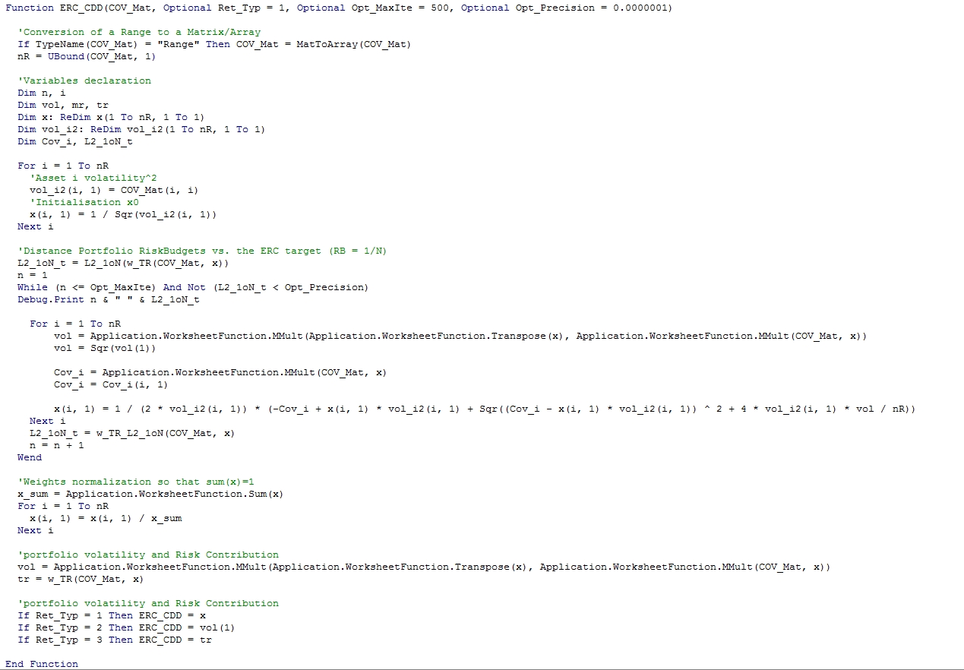

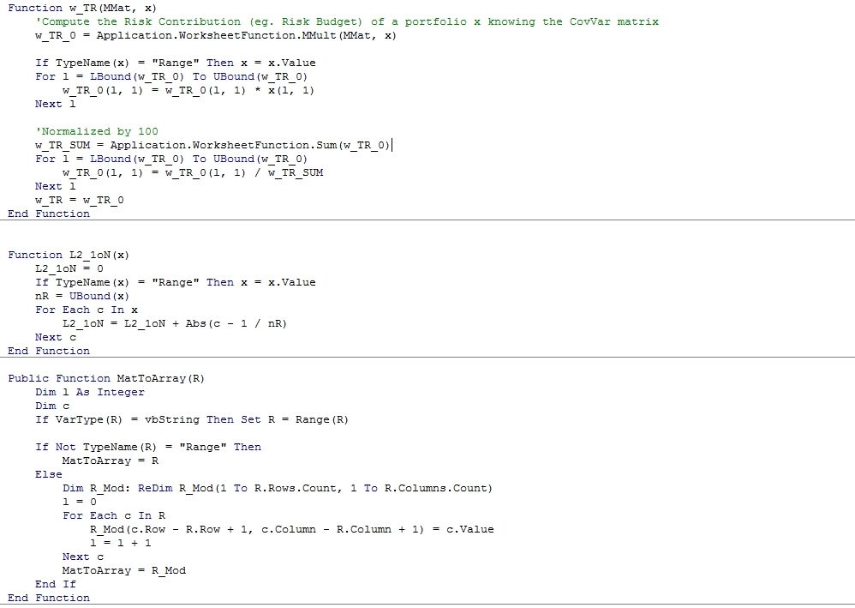

**Reference**

Richard, Jean-Charles and Roncalli, Thierry, Smart Beta: Managing Diversification of Minimum Variance Portfolios (March 2015). Available at SSRN: <https://ssrn.com/abstract=2595051>